WMF LOCAL OFFICERS YEAR 2023
PLEASE FILL IN AS COMPLETELY AS POSSIBLE (including phone and email) and send to WMF Executive Secretary, Dawn Johnson at 2991 30th Ave., Wilson, WI 54027 and if there are any changes during the year, please notify me. Thanks!!
WMF President ______________________________________________________________
Mailing Address________________________________________________________
City_________________________________ State_________ Zip ________________
Phone: Home (_______) __________________ Cell (_______)__________________
Email_________________________________________________________________
I am ok with this email being used to send a WMF email newsletter.
WMF Treasurer ______________________________________________________________
Mailing Address________________________________________________________
City_________________________________ State_________ Zip ________________
Phone: Home (_______) __________________ Cell (_______)__________________
Email_________________________________________________________________
I am ok with this email being used to send a WMF email newsletter.
Please fill in the information below:
Church Name __________________________________________________________
Women’s Group name___________________________________________________
Mailing Address_________________________________________________________
City_______________________________ State_____________ Zip _______________
Email__________________________________________________________________
Pastor’s Name___________________________ Pastor’s wife’s Name______________
Pastor’s Mailing Address__________________________________________________
City________________________________ State_____________ Zip ______________
Please check here if you prefer that all mailings be sent to the Church address.
THANK YOU!!

Make plans to attend
WMF Day 2023
June 14, 2023
held in Sioux Falls SD
our theme will be:
Rescued and Redeemed
Colossians 1:13-14 NIV

2023 WMF BIBLE STUDY
Women of Redemption
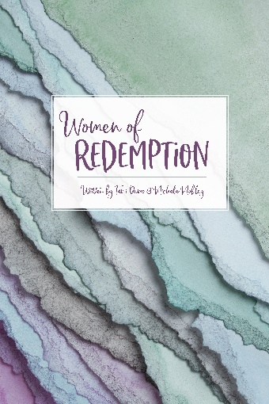
Written by Tami Demo and Michele Mobley

Throughout this Bible study we hope for you to learn that God’s perfect plan does not depend on your perfect obedience but on God’s perfect Sovereignty. We will look at these Old Testament women who lived imperfect lives and yet God’s plans still prevailed. Be encouraged that God’s will is sovereign no matter how flawed we are. Just like the women of redemption in this study, God rescues us from our sin, we are restored to a relationship with Him and through His faithfulness, we are redeemed.
“For He has rescued us from the dominion of darkness and brought us into the kingdom of the Son He loves, in whom we have redemption, the forgiveness of sins.” Colossians 1:13-14

The 2023 WMF Bible study Women of Redemption will be $13 each.

_______Number of copies
Mail to: Name_______________________________________________________
Address_____________________________________________________
City___________________________ State________ Zip______________
Church name ________________________________________________
City _________________________________ State__________________

PLEASE make checks to WMF of AFLC and send this order form with payment to Executive Secretary Dawn Johnson, 2991 30th Ave. Wilson WI 54027.

The studies will be mailed out when they are received from the printer.

Date: _______________

2023 TRANSMITTAL FORM
Women’s Missionary Federation
of the Association of Free Lutheran Congregations

PLEASE FILL IN INFORMATION COMPLETELY: (Use back if necessary)

Church Name/City/State _________________________________________________
Name of WMF: _________________________________________________________________
Pastor: ________________________________________________________________________
Treasurers Name: ___________________________________ Phone:______________________
Address_______________________________________________________________________

$ AMOUNT

__________ CHRISTIAN EDUCATION: (April, August, and December)
(divided evenly between Parish Ed and AFLC Schools or designate below)
__________ Parish Education
__________ FLBC/FLS
__________ HOME MISSIONS: (March, July, and November)

__________ WORLD MISSIONS: (February, June, and October)

__________ WMF GENERAL FUND: (January, May, and September)

__________ CONVENTION OFFERING: (divided between all 4 projects)

____________ TOTAL AMOUNT CHECK #_____________

___________ IN MEMORIAM:
In Memory of: _____________________________________________________
City, State: _______________________________________________________
Designate your donation to: ____World Missions ____Home Missions ___Parish Ed
___ FLBC ___ FLS ___WMF General Fund
_________ HONORARY MEMBER PINS: ($13 each pin. Donations go to World Missions)

Please make one check payable to WMF OF AFLC
Mail to the National Treasurer, Margie Lee, PO Box 118, Beulah ND 58523
Any questions, call 701-870-2259 or email at margieleend@gmail.com

